* Task 1: Create and configure Azure AD users
* Navigate back to the **Users - All users** blade, and then click **+ New user**.
* Create a new user

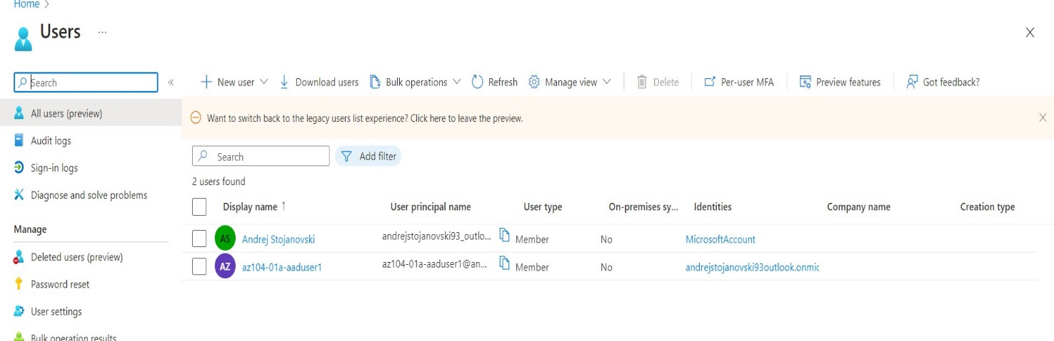

**Note**: While this user account can access the Azure Active Directory tenant, it does not have any access to Azure resources. This is expected, since such access would need to be granted explicitly by using Azure Role-Based Access Control.

1. In the **InPrivate** browser window, on the Azure AD blade, scroll down to the **Manage** section, click **User settings**, and note that you do not have permissions to modify any configuration options.

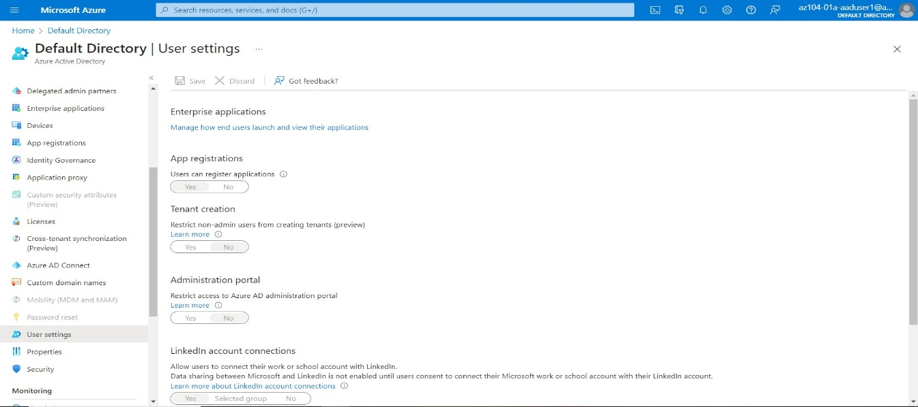

Task 2: Create Azure AD groups with assigned and dynamic membership

* verify that the activation was successful.
* 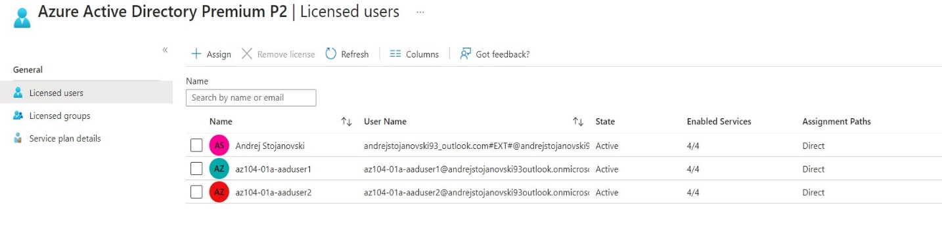
* Use the **+ New group** button to create a new group
* 